Design Patterns Lab Manual(Hand Book)

**1Q. Design and implement ShapeFactory class that generates different types of Shape objects (Circle, Square, Rectangle) based on input parameters using Factory Design Pattern.**

**ANS:**

**Code Implementation**

class Shape:

    def draw(self): pass

class Circle(Shape):

    def draw(self): return "Drawing Circle"

class Square(Shape):

    def draw(self): return "Drawing Square"

class Rectangle(Shape):

    def draw(self): return "Drawing Rectangle"

class ShapeFactory:

    @staticmethod

    def create_shape(shape_type):

        shapes = {'circle': Circle, 'square': Square, 'rectangle': Rectangle}

        return shapes.get(shape_type.lower())()

# Client Code

shape1 = ShapeFactory.create_shape('circle')

shape2 = ShapeFactory.create_shape('square')

print(shape1.draw())  # Output: Drawing Circle

print(shape2.draw())  # Output: Drawing Square

OUTPUT:

Drawing Circle

Drawing Square

**Explained**

**1. Abstract Base Class: Shape**

• **Shape**: This is an abstract base class that defines a common interface for all shapes.

• The draw method is defined but not implemented (using pass), which means that any subclass must implement this method.

#### **2. Concrete Shape Classes**

• **Circle**, **Square**, and **Rectangle** are concrete implementations of the Shape class.

• Each of these classes implements the draw method to provide specific behavior. For instance, Circle returns "Drawing Circle", and so on.

**3. ShapeFactory Class**

• ShapeFactory: This is the factory class responsible for creating shape objects.

• The create_shape method is a static method that takes shape_type as an argument.

• A dictionary named shapes maps shape type names (in lowercase) to their corresponding classes.

• The method retrieves the appropriate class from the dictionary based on the input string and creates an instance of that class using ()

**4. Client Code**

• The client code calls the create_shape method on the ShapeFactory to create a Circle and a Square.

• It then calls the draw method on each shape instance and prints the output.

### Summary

* This implementation of the **Factory Design Pattern** encapsulates the creation logic of different shape objects within the ShapeFactory.
* Clients can create different shapes without needing to know the specifics of how those shapes are implemented, adhering to the principle of separation of concerns.

**UML Diagram**

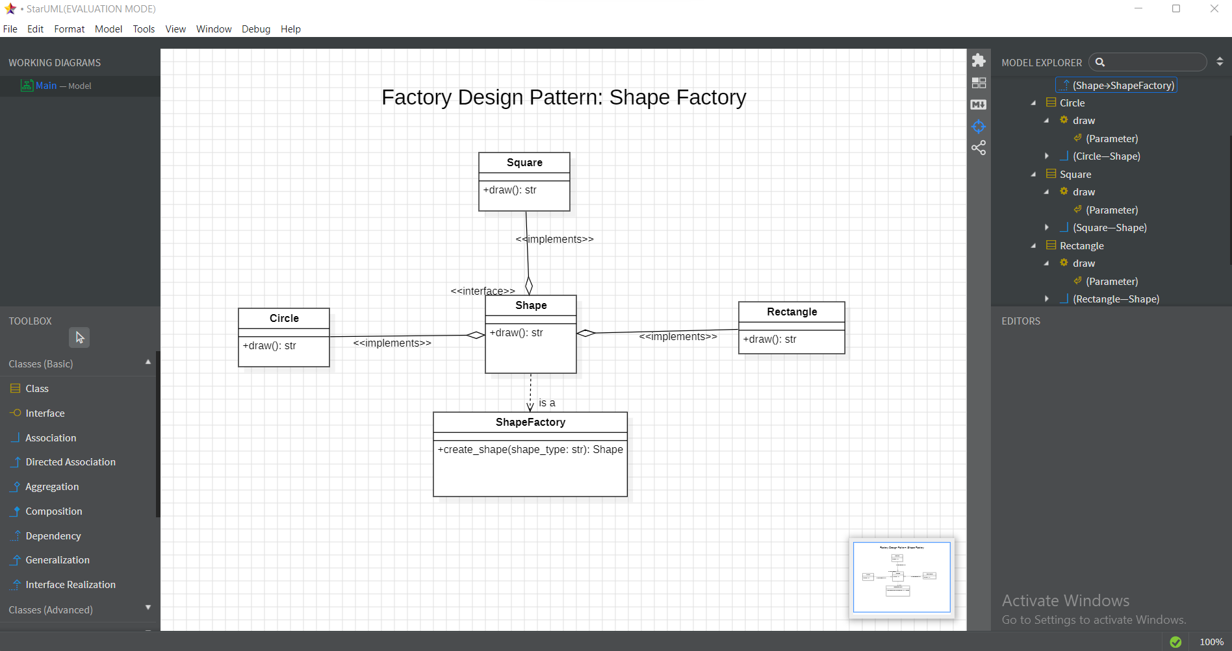

**2 Q. Design and Implement an AbstractFactory class to create families of related or dependent objects with respect to decathlon store without specifying their concrete classes using Abstract Factory?**

**ANS:**

**Code implementation**

from abc import ABC, abstractmethod

# Abstract Products

class Shoes(ABC):

    @abstractmethod

    def type(self): pass

class Clothes(ABC):

    @abstractmethod

    def type(self): pass

# Concrete Products

class RunningShoes(Shoes):

    def type(self): return "Running Shoes"

class SwimmingSuit(Clothes):

    def type(self): return "Swimming Suit"

# Abstract Factory

class SportsFactory(ABC):

    @abstractmethod

    def create_shoes(self): pass

    @abstractmethod

    def create_clothes(self): pass

# Concrete Factory

class DecathlonFactory(SportsFactory):

    def create_shoes(self): return RunningShoes()

    def create_clothes(self): return SwimmingSuit()

# Client Code

factory = DecathlonFactory()

print(factory.create_shoes().type())  # Output: Running Shoes

print(factory.create_clothes().type())  # Output: Swimming Suit

OUTPUT:

Running Shoes

Swimming Suit

**Explained**

**1 Abstract Product Classes**

• **Shoes** and **Clothes**: These are abstract base classes that define the interface for different types of products.

• The type method is declared as an abstract method, meaning any subclass must implement this method to provide specific behavior.

**2 Concrete Product Classes**

• **RunningShoes** and **SwimmingSuit**: These classes are concrete implementations of the abstract product classes.

• Each class implements the type method to return a specific product description.

**3. Abstract Factory Class**

**SportsFactory**: This is an abstract factory class that declares methods for creating products. It defines the methods create_shoes and create_clothes, which must be implemented by any concrete factory.

**4. Concrete Factory Class**

**DecathlonFactory**: This class is a concrete implementation of the SportsFactory. It provides the implementation for the methods to create specific products (i.e., RunningShoes and SwimmingSuit).

**5. Client Code**

* The client code creates an instance of DecathlonFactory.
* It calls the create_shoes method to create a RunningShoes object and then calls the type method to get its description.
* Similarly, it creates a SwimmingSuit object and retrieves its description.

### Summary

* This implementation demonstrates the **Abstract Factory Pattern**, which allows the creation of families of related or dependent objects (in this case, shoes and clothes) without specifying their concrete classes.
* The use of abstract classes and methods helps in providing a clear interface and facilitates the creation of new products by simply extending the existing structure without modifying the client code.

**UML Diagram**

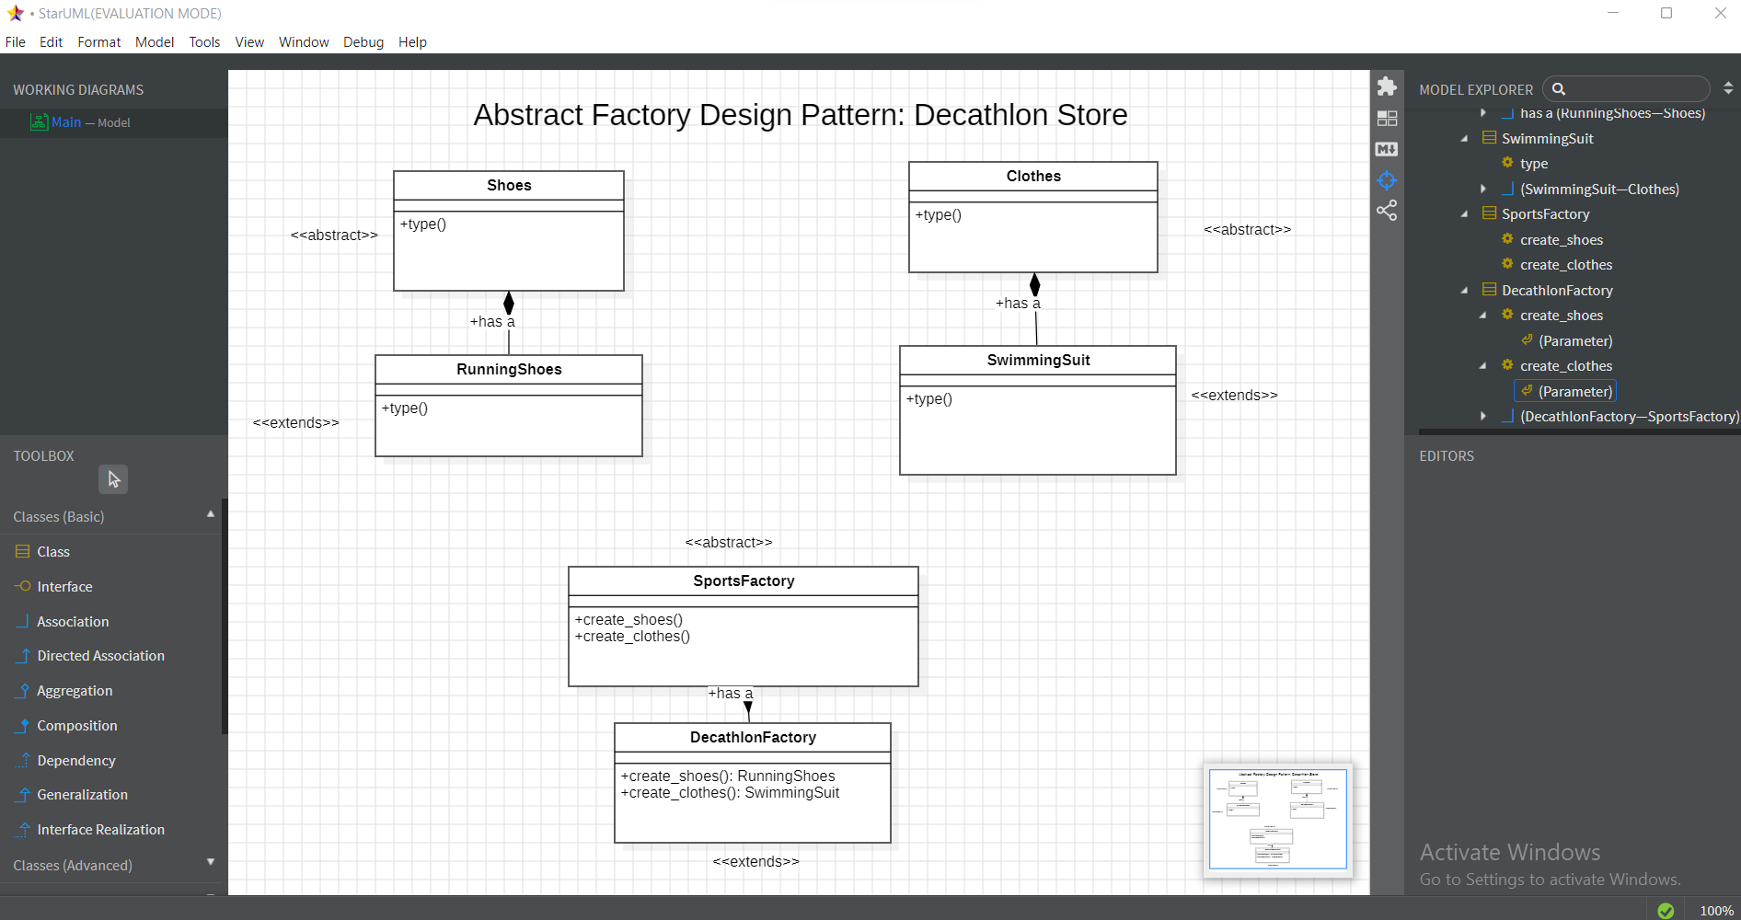

**3 Q. Design and implement a complex object like a House using a step-by-step Builder pattern, allowing different representations of the house (wooden, brick, etc.).?**

ANS:

class House:

    def __init__(self, foundation, roof, interior):

        self.foundation = foundation

        self.roof = roof

        self.interior = interior

    def __str__(self):

        return f"House with {self.foundation}, {self.roof}, and {self.interior}"

# Builder Interface

class HouseBuilder:

    def build(self):

        pass

# Wooden House Builder

class WoodenHouseBuilder(HouseBuilder):

    def build(self):

        return House("Wooden foundation", "Wooden roof", "Wooden interior")

# Brick House Builder

class BrickHouseBuilder(HouseBuilder):

    def build(self):

        return House("Concrete foundation", "Tile roof", "Modern interior")

# Director

class Director:

    def __init__(self, builder):

        self.builder = builder

    def construct_house(self):

        return self.builder.build()

# Client Code

if __name__ == "__main__":

    # Build Wooden House

    wooden_house = Director(WoodenHouseBuilder()).construct_house()

    print(wooden_house)

    # Build Brick House

    brick_house = Director(BrickHouseBuilder()).construct_house()

    print(brick_house)

OUTPUT

House with Wooden foundation, Wooden roof, and Wooden interior

House with Concrete foundation, Tile roof, and Modern interior

**Explained**

**1.House Class**:

* Represents the complex object (House) that is being constructed.
* The constructor takes three parameters: foundation, roof, and interior.
* The __str__ method provides a string representation of the house, detailing its components.

**2.Builder Interface**:

* An abstract base class that defines a method build that concrete builders will implement.

**3.Concrete Builders**:

* **WoodenHouseBuilder**: Implements the build method to create a wooden house with specific components.
* **BrickHouseBuilder**: Implements the build method to create a brick house with its own set of components.

**4.Director Class**:

* This class takes a builder instance and orchestrates the construction process. It provides a construct_house method to build the house.

**5.Client Code**:

* The if __name__ == "__main__": block demonstrates how to use the builder and director to construct a wooden house and a brick house, and print their details.

### Summary

* This implementation of the **Builder Pattern** allows for the creation of different representations of a complex object (House) by using specific builders.
* The use of the **Director** class simplifies the process of constructing the object, encapsulating the construction logic away from the client code.
* This pattern promotes separation of concerns and enhances code maintainability and flexibility, as adding new types of houses can be done by creating new builder classes without modifying existing code.

**UML Diagram**

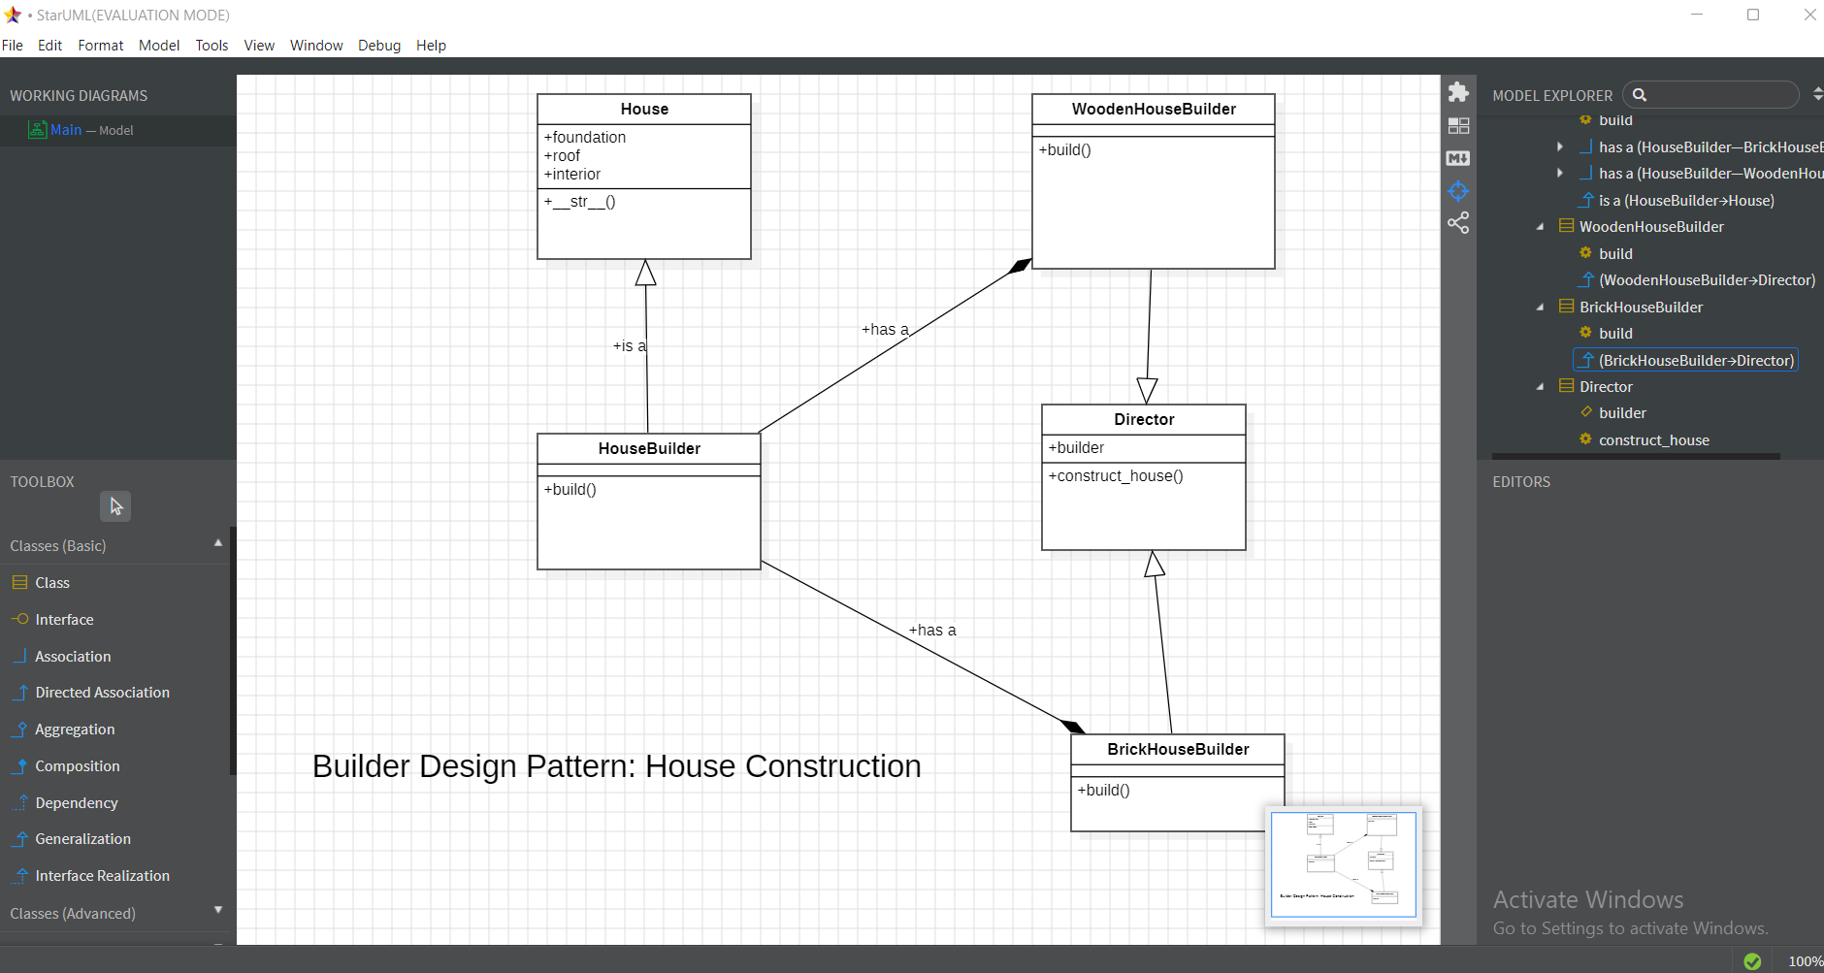

**4 Q.Design and Implement to Extend a Coffee object with dynamic features (e.g., milk, sugar, whipped cream) using Decorators?**

**AND**

**Code Implementation**

# Base Coffee class

class Coffee:

    def cost(self):

        return 5  # Base cost of coffee

# Base Decorator class

class CoffeeDecorator(Coffee):

    def __init__(self, coffee):

        self._coffee = coffee

    def cost(self):

        return self._coffee.cost()

# Concrete Decorators

class MilkDecorator(CoffeeDecorator):

    def cost(self):

        return self._coffee.cost() + 1  # Add cost of milk

class SugarDecorator(CoffeeDecorator):

    def cost(self):

        return self._coffee.cost() + 0.5  # Add cost of sugar

class WhippedCreamDecorator(CoffeeDecorator):

    def cost(self):

        return self._coffee.cost() + 1.5  # Add cost of whipped cream

# Client Code

if __name__ == "__main__":

    coffee = Coffee()  # Basic coffee

    coffee_with_milk = MilkDecorator(coffee)  # Coffee with milk

    coffee_with_milk_sugar = SugarDecorator(coffee_with_milk)  # Coffee with milk and sugar

    coffee_full = WhippedCreamDecorator(coffee_with_milk_sugar)  # Coffee with milk, sugar, and whipped cream

    print(f"Total cost: ${coffee_full.cost():.2f}")  # Output: Total cost: $8.00

**OUTPUT**

Total cost: $8.00

**Explained**

1 **Base Coffee Class**:

* Represents the core object with a base cost. In this case, the base cost of coffee is set to $5.

2 **Base Decorator Class**:

* This class inherits from Coffee and serves as a base for all decorators. It holds a reference to a Coffee object.

**3 Concrete Decorators**:

* Each concrete decorator enhances the base coffee object by adding a specific cost:
  + **MilkDecorator**: Adds $1 to the coffee cost.
  + **SugarDecorator**: Adds $0.5 to the coffee cost.
  + **WhippedCreamDecorator**: Adds $1.5 to the coffee cost

**4. Client Code**:

* This section of the code demonstrates how to use the decorators to create a customized coffee order.
* It starts with a basic Coffee object and then decorates it step by step:
  + Adding milk.
  + Adding sugar.
  + Finally, adding whipped cream.
* The total cost is printed out.

### Summary

* This implementation of the **Decorator Pattern** allows for the dynamic addition of functionalities (in this case, additional ingredients) to an object (coffee) without modifying its structure.
* The pattern promotes code reusability and adheres to the **Open/Closed Principle**, as new decorators can be added without changing the existing codebase.
* The total cost is computed at runtime based on the selected decorators, demonstrating flexibility in object enhancement.

**UML Diagram**

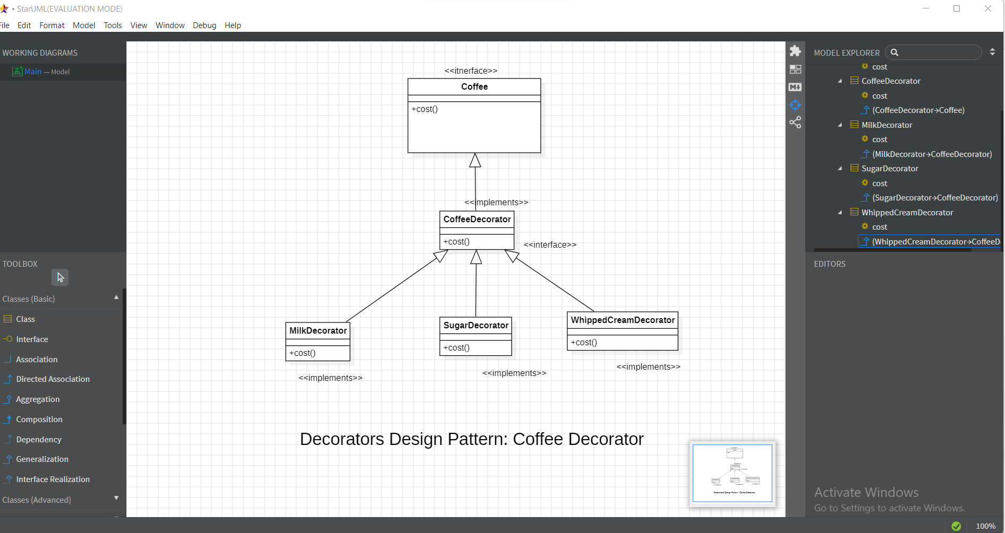

**5Q.Design and Implement a Logger class ensuring a single instance throughout the application?**

**ANS:**

class Logger:

    _instance = None

    def __new__(cls):

        if cls._instance is None:

            cls._instance = super(Logger, cls).__new__(cls)

        return cls._instance

    def log(self, message):

        print(f"Log: {message}")

# Client Code

logger1 = Logger()

logger2 = Logger()

logger1.log("This is a log message.")

print(logger1 is logger2)  # Output: True

OUTPUT:

Log: This is a log message.

True

• The Logger class is defined to implement the Singleton pattern, ensuring that only one instance of the class exists throughout the application.

• _instance is a class variable that holds the single instance of the Logger class. Initially, it's set to None.

• The __new__ method is responsible for creating a new instance of the class. It is a static method called before __init__.

• The method checks if _instance is None (i.e., no instance exists yet). If so, it creates a new instance using super(Logger, cls).__new__(cls) and assigns it to _instance.

• If an instance already exists, it simply returns the existing instance stored in _instance.

• This ensures that any call to create a Logger instance will return the same instance.

• The log method takes a message as a parameter and prints it prefixed by "Log: ".

• This method is used to log messages to the console.

• Two variables, logger1 and logger2, are assigned to instances of the Logger class.

• Because of the Singleton implementation, both logger1 and logger2 point to the same instance of Logger. Hence, the print(logger1 is logger2) statement evaluates to True, confirming that both references point to the same object in memory.

• The line logger1.log("This is a log message.") logs the message using the log method of the Logger instance.

**Summary**

* This implementation effectively creates a Singleton Logger class that ensures only one instance is created and used across the application. Whenever you need to log a message, you can use the Logger class without worrying about creating multiple instances. This is particularly useful for maintaining consistent logging behavior in applications.

**UML Diagram**

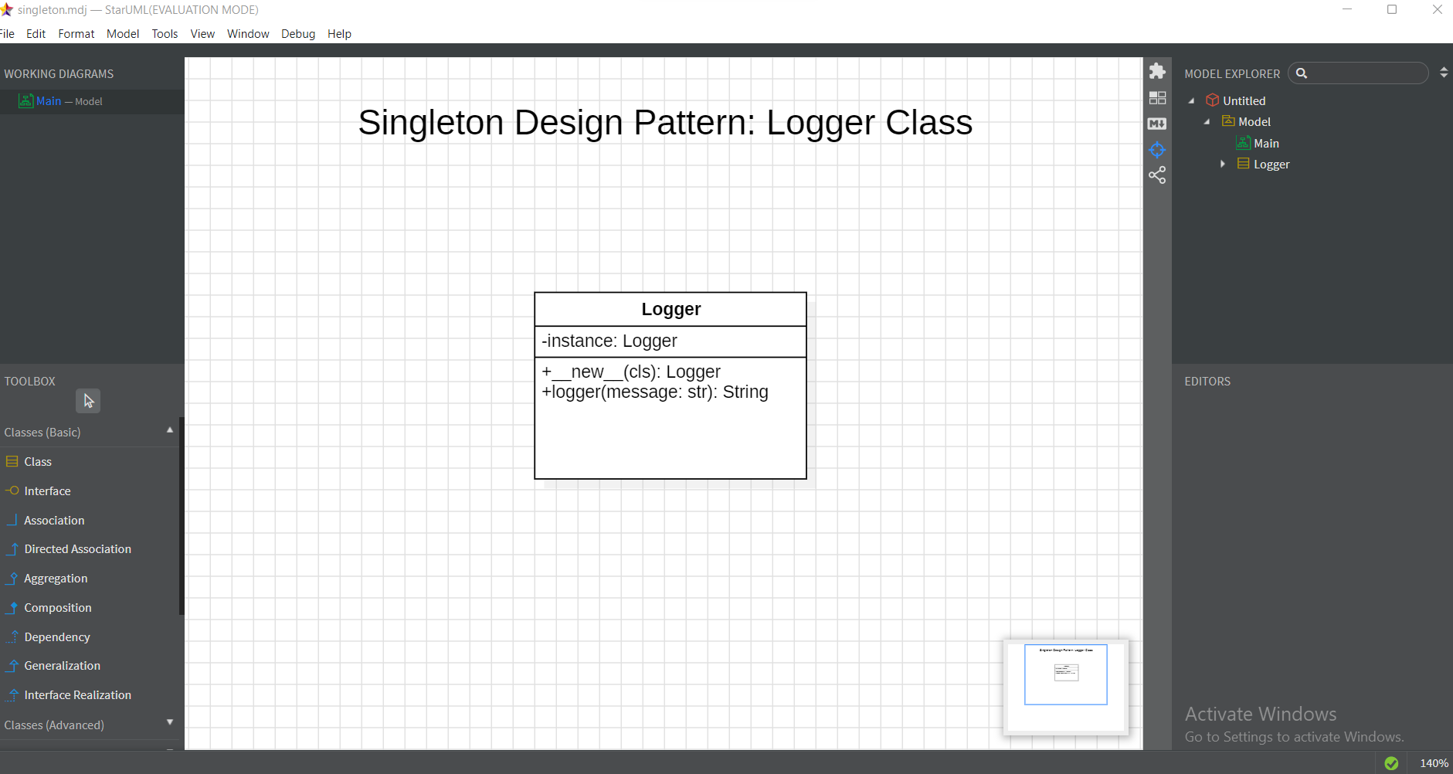

**6 Q. Design and implement an Adapter Pattern for a Music System?**

**AND:**

**Code Implementation**

# Step 1: Define the Old Music Player interface

class OldMusicPlayer:

    def play_cd(self, cd_name: str):

        raise NotImplementedError("This method should be overridden.")

# Step 2: Implement the Modern Music Player

class ModernMusicPlayer:

    def play_streaming(self, song_name: str):

        print(f"Playing {song_name} from a streaming service.")

# Step 3: Create an Adapter that adapts ModernMusicPlayer to OldMusicPlayer

class StreamingAdapter(OldMusicPlayer):

    def __init__(self, modern_player: ModernMusicPlayer):

        self.modern_player = modern_player

    def play_cd(self, cd_name: str):

        # Adapting the play_cd method to use the play_streaming method of ModernMusicPlayer

        print(f"Adapting CD '{cd_name}' to a streaming song.")

        self.modern_player.play_streaming(cd_name)

# Step 4: Client code demonstrating the Adapter Pattern

if __name__ == "__main__":

    # Create a modern music player

    modern_player = ModernMusicPlayer()

    # Use the adapter to connect the modern player to the old system

    adapter = StreamingAdapter(modern_player)

    # Now play a "CD" (which is really a streaming song)

    adapter.play_cd("Classic Hits")

OUTPU:

Adapting CD 'Classic Hits' to a streaming song.

Playing Classic Hits from a streaming service.

**Explained**

1 **Old Music Player Interface**:

* This is the target interface that we want to adapt to. It defines a method play_cd, which is supposed to be implemented by any class that follows this interface.

2 **Modern Music Player**:

* This class represents the existing implementation that does not adhere to the OldMusicPlayer interface. It has a method play_streaming for playing songs from a streaming service.

3 **Streaming Adapter**:

* This is the adapter class that allows ModernMusicPlayer to be used where OldMusicPlayer is expected. It inherits from OldMusicPlayer and implements the play_cd method.
* Inside play_cd, it adapts the call to use play_streaming of ModernMusicPlayer.

4 **Client Code**:

* In the if __name__ == "__main__": block, we create an instance of ModernMusicPlayer and then create an adapter (StreamingAdapter) that connects it to the OldMusicPlayer interface.
* When play_cd is called on the adapter, it internally calls the modern player's method, effectively bridging the gap between the two interfaces.

### Summary

* The **Adapter Pattern** is useful when you want to allow two incompatible interfaces to work together.
* In this example, StreamingAdapter allows the modern music player to be used in a system that expects an old music player interface.
* This approach promotes code reuse and flexibility, allowing new implementations to be added without altering existing code structures.

**UML Diagram**

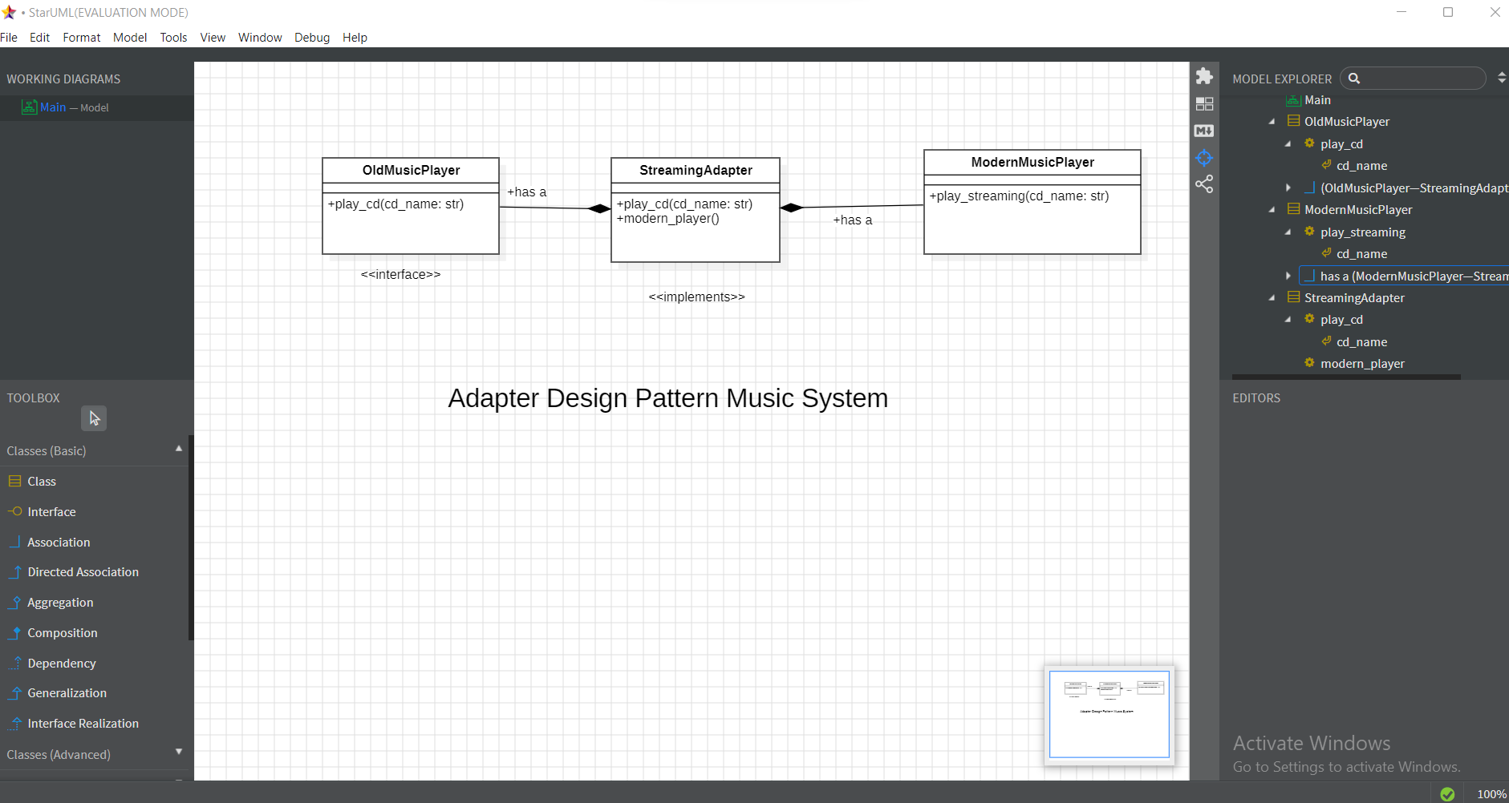

**7 Q. Design and Implement an Observer pattern for a news agency to notify subscribers of updates?**

**AND:**

**Code Implementation**

# Subject (News Agency)

class NewsAgency:

    def __init__(self):

        self.subscribers = []

        self.news = ""

# Subscribe a subscriber to the agency

    def subscribe(self, subscriber):

        self.subscribers.append(subscriber)

    # Notify all subscribers about the new news

    def notify(self):

        for subscriber in self.subscribers:

            subscriber.update(self.news)

    # Set the news and notify all subscribers

    def set_news(self, news):

        self.news = news

        self.notify()

# Observer (Subscriber)

class Subscriber:

    def update(self, news):

        print(f"News received: {news}")

# Client Code

if __name__ == "__main__":

    # Create the news agency (Subject)

    agency = NewsAgency()

    # Create subscriber instances (Observers)

    sub1 = Subscriber()

    sub2 = Subscriber()

    # Subscribe the subscribers to the news agency

    agency.subscribe(sub1)

    agency.subscribe(sub2)

    # Set the news and notify all subscribers

    agency.set_news("Breaking News: Observer Pattern in Python!")

OUTPUT:

News received: Breaking News: Observer Pattern in Python!

News received: Breaking News: Observer Pattern in Python!

**Explained**

**1 Subject (News Agency)**:

* This class maintains a list of subscribers and manages the news updates. It provides methods to subscribe and unsubscribe subscribers and notify them when there is new news.
* **Key Methods**:
* subscribe: Adds a subscriber to the list.
* unsubscribe: Removes a subscriber from the list.
* notify: Calls the update method on all subscribed observers when news is available.
* add_news: Sets the news and triggers the notification.

**2 Observer (Subscriber)**:

* This class represents the observers who are interested in receiving updates from the NewsAgency. Each subscriber has a name and an update method that receives the news.

**3 Client Code**:

* In the main block, a NewsAgency instance is created, along with two Subscriber instances. The subscribers subscribe to the news agency and then the agency adds news, which triggers notifications to all subscribers.

### Summary

* The **Observer Pattern** allows a subject to notify multiple observers about changes in its state, which is useful for implementing distributed event handling systems.
* In this example, the NewsAgency acts as the subject that maintains a list of subscribers (observers) and notifies them of any news updates.
* This pattern promotes loose coupling between the subject and its observers, making the system more flexible and maintainable.

**UML Diagram**

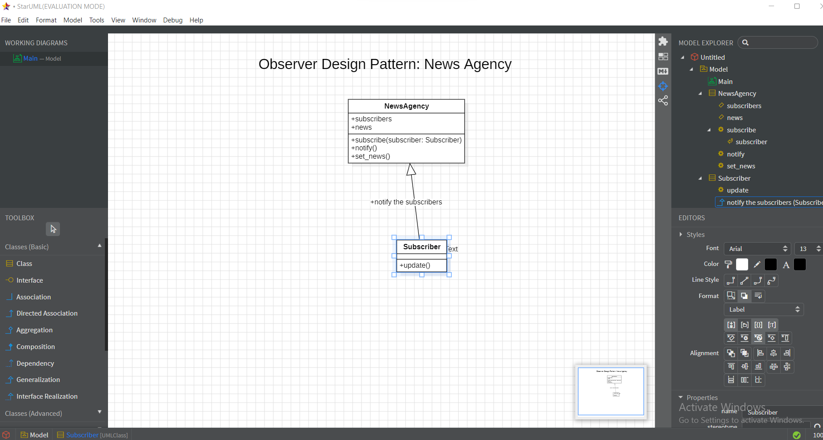

**8Q. Design and Implement a Façade pattern for home theatre system?**

**ANS:**

**Code Implementation**

class TV:

    def on(self): print("TV ON")

    def off(self): print("TV OFF")

class SoundSystem:

    def on(self): print("Sound ON")

    def off(self): print("Sound OFF")

class Lights:

    def dim(self): print("Lights DIM")

    def bright(self): print("Lights BRIGHT")

class HomeTheatreFacade:

    def __init__(self):

        self.tv = TV()

        self.sound = SoundSystem()

        self.lights = Lights()

def watch_movie(self):

        self.lights.dim(); self.tv.on(); self.sound.on()

    def end_movie(self):

        self.tv.off(); self.sound.off(); self.lights.bright()

# Client Code

home_theatre = HomeTheatreFacade()

home_theatre.watch_movie()  # Start movie

home_theatre.end_movie()    # End movie

OUTPUT:

Lights DIM

TV ON

Sound ON

TV OFF

Sound OFF

Lights BRIGHT

**Explained**

**1 Subsystem Classes**:

* These classes represent the various components of the home theater system.
* Each class has methods to turn the component on or off (for TV and SoundSystem) or to dim or brighten the lights (for Lights).

**2 Facade Class**:

* The HomeTheatreFacade class provides a unified interface to the subsystem.
* The constructor initializes instances of TV, SoundSystem, and Lights.
* The watch_movie method dims the lights, turns on the TV, and activates the sound system.
* The end_movie method turns off the TV and sound system, and brightens the lights.

**3 Client Code**:

* This section demonstrates how to use the façade
* The client interacts only with the HomeTheatreFacade, making it simple to start and end a movie without needing to manage each component individually.

### Summary

* The **Facade Pattern** simplifies the interface to a complex system by providing a single class that manages interactions between the system components.
* In this example, the HomeTheatreFacade class abstracts the complexity of controlling the TV, SoundSystem, and Lights, allowing the client to perform operations like watching or ending a movie with minimal effort. This pattern promotes code readability and usability.

**UML Diagram**

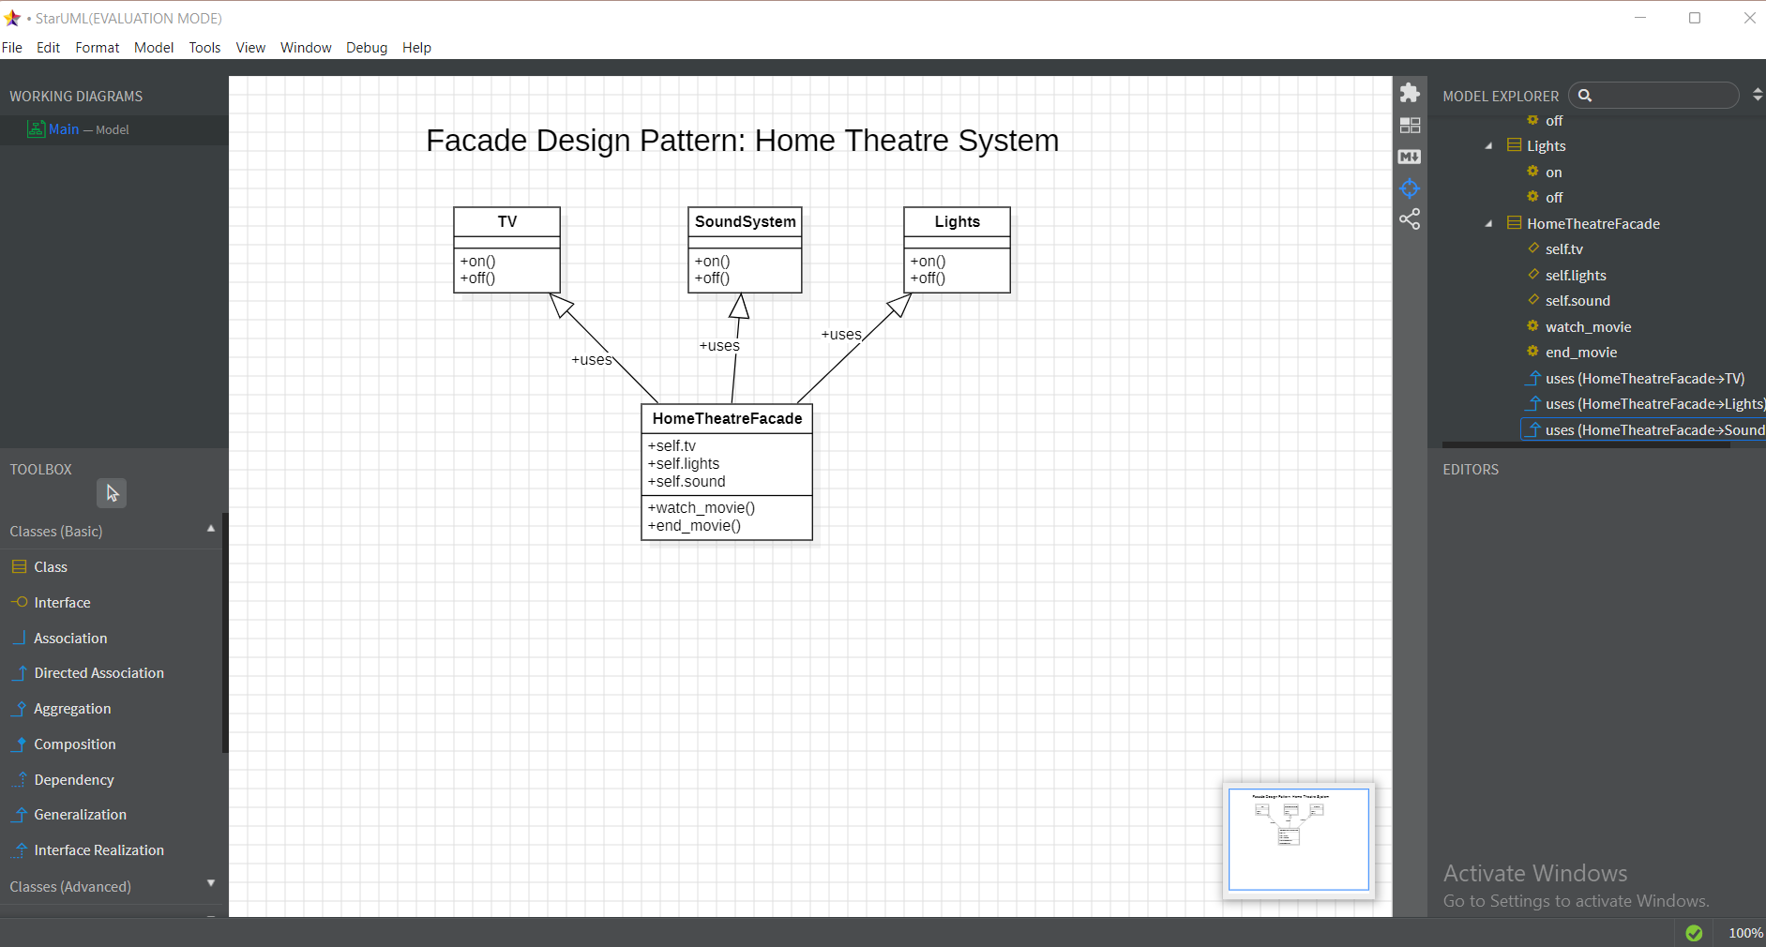

**9 Q.Design and Implement a Template Method for Document Processing (word, pdf, excel)?**

**ANS:**

class DocumentProcessor:

    def process(self):

        self.open_file(); self.read_data(); print("File closed")

class WordProcessor(DocumentProcessor):

    def open_file(self): print("Word opened")

    def read_data(self): print("Reading Word")

class PDFProcessor(DocumentProcessor):

    def open_file(self): print("PDF opened")

    def read_data(self): print("Reading PDF")

# Client Code

WordProcessor().process()

PDFProcessor().process()

OUTPUT:

Word opened

Reading Word

File closed

PDF opened

Reading PDF

File closed

1 **Abstract Class**:

* The DocumentProcessor class defines the template method process() and the common steps involved in processing a document.
* In the process() method, the steps for processing a document are defined, but the specific implementations for opening and reading files are delegated to subclasses through the methods open_file() and read_data().

2 **Concrete Classes**:

* The WordProcessor and PDFProcessor classes provide specific implementations for the steps defined in DocumentProcessor.

3 **Client Code**:

* The client code demonstrates how to use the template method with both concrete classes
* When you call process() on a WordProcessor instance, it will open a Word document and read its data. The same applies to the PDFProcessor, which processes a PDF file.

### Summary

* The **Template Method Pattern** allows you to define a common process (in this case, processing documents) while allowing subclasses to specify the details of certain steps.
* The DocumentProcessor class provides the structure for the algorithm, while WordProcessor and PDFProcessor provide their specific implementations. This promotes code reuse and adherence to the **DRY** (Don't Repeat Yourself) principle.

**UML Diagram**

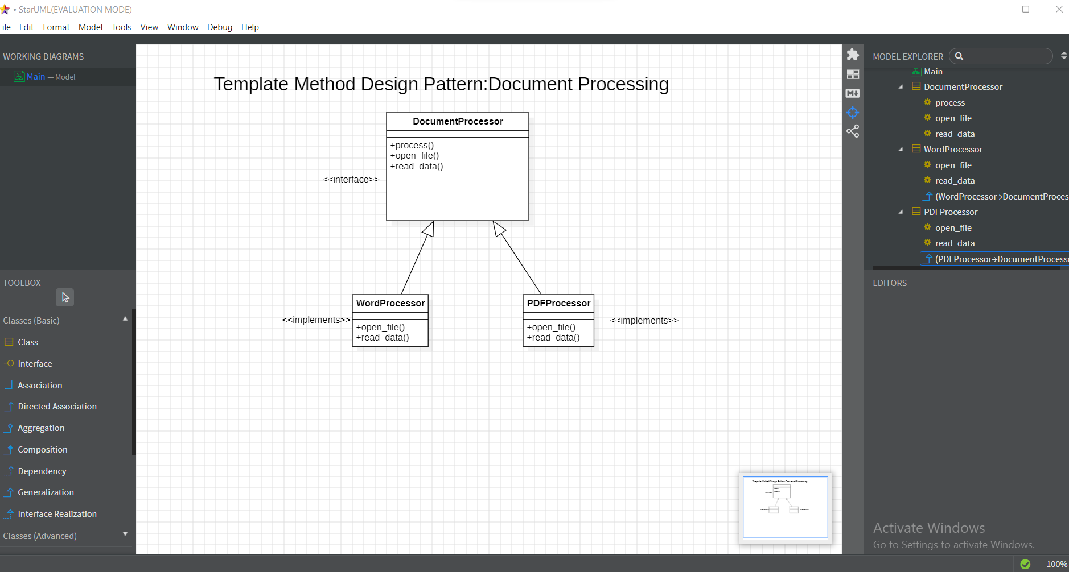

**10 Q. Design and Implement weather monitoring system that notifies multiple display devices whenever the weather conditions change that follows the Observer Design Pattern?**

**AND**

**Code Implementation**

class WeatherStation:

    def __init__(self):

        self.subscribers = []

        self.temperature = 0

    def subscribe(self, subscriber):

        self.subscribers.append(subscriber)

    def notify(self):

        for sub in self.subscribers:

            sub.update(self.temperature)

    def set_temperature(self, temp):

        self.temperature = temp

        self.notify()

class DisplayDevice:

    def update(self, temp):

        print(f"Temperature updated: {temp}°C")

# Client Code

station = WeatherStation()

display1 = DisplayDevice()

display2 = DisplayDevice()

station.subscribe(display1)

station.subscribe(display2)

station.set_temperature(25)  # Notify displays

OUTPUT:

Temperature updated: 25°C

Temperature updated: 25°C

Explained

1 **Subject Class**:

* The WeatherStation class acts as the subject that maintains a list of observers (subscribers) and notifies them of any changes (in this case, the temperature).
* The subscribe() method allows an observer to subscribe to updates, while the notify() method sends the current temperature to all subscribed observers. The set_temperature() method changes the temperature and triggers notifications.

**2 Observer Class**:

* The DisplayDevice class represents the observer that gets updated with the temperature.

**3 Client Code**:

* The client code demonstrates how to use the observer pattern with the WeatherStation and DisplayDevice.
* When set_temperature(25) is called, both display devices are notified of the temperature change.

### Summary

* The **Observer Design Pattern** is useful when you want to create a subscription model where multiple objects (observers) are notified about changes in another object (subject).
* In this implementation, the WeatherStation serves as the subject that tracks its state (temperature) and notifies all registered DisplayDevice instances whenever the temperature changes.

UML Diagram

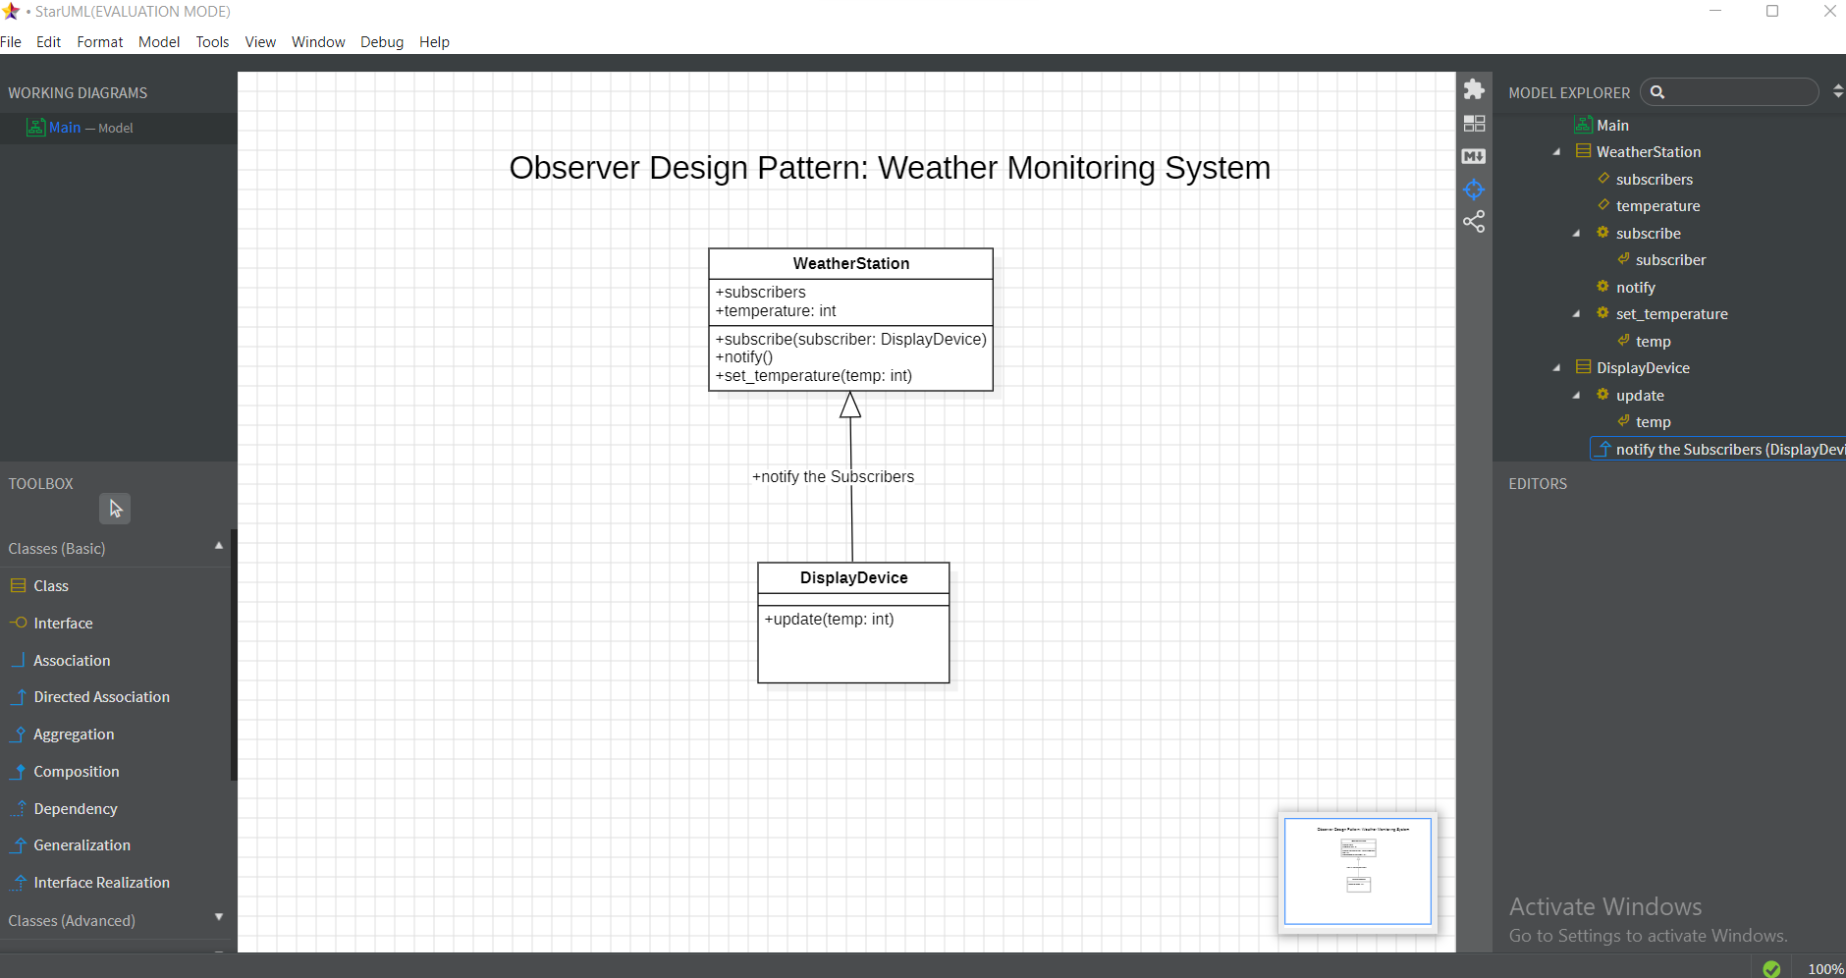

**11 Q. Design and Implement a Proxy pattern to control access to an object (e.g., a protected resource or remote service).?**

**ANS:**

**Code Implementation**

class RealResource:

    def access_resource(self):

        return "Accessing protected resource."

class Proxy:

    def __init__(self, user):

        self.user = user

        self.resource = RealResource()

    def access(self):

        if self.user == "admin":

            return self.resource.access_resource()

        return "Access denied."

# Client Code

proxy1 = Proxy("admin")

proxy2 = Proxy("guest")

print(proxy1.access())  # Allowed

print(proxy2.access())  # Denied

OUTPUT

Accessing protected resource.

Access denied.

**Explained**

1 **Real Subject Class**:

* The RealResource class represents the actual resource that clients want to access. It has a method to access the resource.
* The access_resource() method simulates accessing the protected resource.

2 **Proxy Class**:

* The Proxy class controls access to the RealResource instance. It checks the user's permissions before allowing access to the resource.
* The __init__() method initializes the proxy with the user and the real resource.
* The access() method checks if the user has permission (i.e., if the user is "admin"). If so, it grants access; otherwise, it denies access.

3 **Client Code**:

* The client code demonstrates how to use the Proxy to control access to the RealResource.
* Two Proxy instances are created: one for an "admin" user and one for a "guest" user.
* When calling access() on proxy1, it allows access to the resource; calling access() on proxy2 denies access.

### Summary

* The **Proxy Design Pattern** is useful when you want to provide a surrogate or placeholder for another object to control access to it.
* In this implementation, the Proxy checks the user's permissions before allowing access to the RealResource, effectively acting as a gatekeeper.

**UML Diagram**

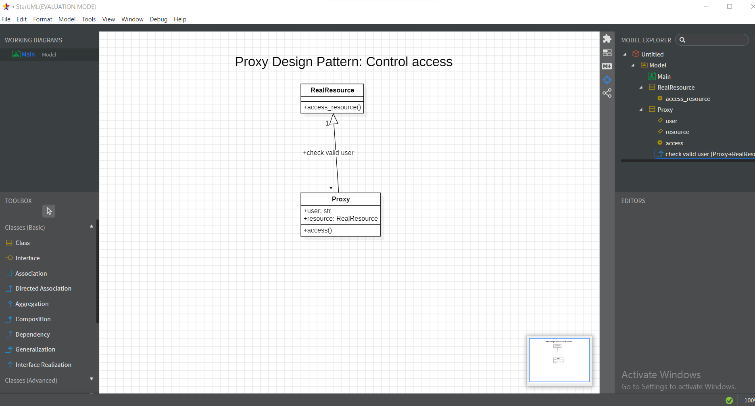

**12. Q. Design and Implement a Mediator pattern to manage communication between a set of objects (e.g., chat room with multiple participants).?**

class ChatRoom:

    def __init__(self):

        self.participants = []

    def add(self, participant):

        self.participants.append(participant)

        participant.room = self

    def send(self, sender, msg):

        for p in self.participants:

            if p != sender: p.receive(msg, sender.name)

class Participant:

    def __init__(self, name): self.name = name

    def send(self, msg): self.room.send(self, msg)

    def receive(self, msg, sender): print(f"{sender}: {msg}")

# Client Code

room = ChatRoom()

alice = Participant("Alice")

bob = Participant("Bob")

room.add(alice)

room.add(bob)

alice.send("Hi Bob!")

OUTPUT:

Alice: Hi Bob!

**Explained**

1 **ChatRoom Class (Mediator)**:

* The ChatRoom class manages the participants and coordinates communication between them.

• **Attributes**:

* participants: A list that holds all participants in the chat room.

• **Methods**:

* add(participant): Adds a participant to the room and assigns the room to the participant.
* send(sender, msg): Sends a message to all participants except the sender.

2 **Participant Class (Colleague)**:

* The Participant class represents users in the chat room.

• **Attributes**:

* name: The name of the participant.

• **Methods**:

* send(msg): Sends a message through the chat room.
* receive(msg, sender): Receives a message from another participant and prints it.

3 **Client Code**:

* The client code demonstrates the interaction between participants through the chat room.

### Summary

* The **Mediator Design Pattern** allows for the decoupling of components by using a mediator to facilitate communication between them.
* In this example, the ChatRoom class serves as the mediator that manages the interaction between Participant instances, making the system more organized and reducing dependencies among the components.

**UML Diagram**

